

A Project Report on

RETAIL POINT OF SALES (POS) SYSTEM

Submitted in partial fulfillment of requirements for the award of the course of

CGB1221-DATABASE MANAGEMENT SYSTEMS
Under the guidance of

Ms.A.Nithyasri
Assistant Professor / AI Submitted By
RUTHUVARSHAN E (927623BAD093)

SUBASH S (927623BAD109)

DEPARTMENT OF ARTIFICIAL INTELLIGENCE AND DATA SCIENCE

M.KUMARASAMY COLLEGE OF ENGINEERING
(Autonomous)

KARUR – 639 113
MAY 2025

M. KUMARASAMY COLLEGE OF ENGINEERING
(Autonomous Institution affiliated to Anna University, Chennai)

KARUR – 639 113

BONAFIDE CERTIFICATE

This is to certify that this project report on “RETAIL POINT OF SALES(POS) SYSTEM” is the bonafide work of RUTHUVARSHAN E (927623BAD093) SUBASH S (927623BAD109) who carried out the project work during the academic year 2024 - 2025 under my supervision.

Signature Signature

Ms.A.NITHYASRI,M.E., Dr. A. SELVI, M.Tech., Ph.D.,

SUPERVISOR, HEAD OF THE DEPARTMENT,

Department of Artificial Intelligence, Department of Artificial Intelligence,
M. Kumarasamy College of Engineering, M. Kumarasamy College of Engineering, Thalavapalayam, Karur - 639 113. Thalavapalayam, Karur - 639 113.

DEPARTMENT OF ARTIFICIAL INTELLIGENCE AND DATA SCIENCE VISION OF THE INSTITUTION
To emerge as a leader among the top institutions in the field of technical education

MISSION OF THE INSTITUTION

- Produce smart technocrats with empirical knowledge who can surmount the global challenges
- Create a diverse, fully-engaged, learner-centric campus environment to provide quality education to the students
- Maintain mutually beneficial partnerships with our alumni, industry, and Professional associations

VISION OF THE DEPARTMENT

To excel in education, innovation, and research in Artificial Intelligence and Data Science to fulfil industrial demands and societal expectations.

MISSION OF THE DEPARTMENT
M1: To educate future engineers with solid fundamentals, continually improving teaching methods using modern tools.
M2: To collaborate with industry and offer top-notch facilities in a conducive learning environment. M3: To foster skilled engineers and ethical innovation in AI and Data Science for global recognition and impactful research.
M4: To tackle the societal challenge of producing capable professionals by instilling employability skills and human values.
PROGRAM EDUCATIONAL OBJECTIVES (PEOs)
Graduates will be able to:
- PEO 1: Compete on a global scale for a professional career in Artificial Intelligence and Data Science.
- PEO 2: Provide industry-specific solutions for the society with effective communication and ethics.
- PEO 3: Hone their professional skills through research and lifelong learning initiatives.

PROGRAM OUTCOMES (POs)
Engineering students will be able to:
- Engineering knowledge: Apply the knowledge of mathematics, science, engineering fundamentals, and an engineering specialization to the solution of complex engineering problems.
- Problem analysis: Identify, formulate, review research literature, and analyze complex engineering problems reaching substantiated conclusions using first principles of mathematics, natural sciences, and engineering sciences.
- Design/development of solutions: Design solutions for complex engineering problems and design system components or processes that meet the specified needs with appropriate consideration for the public health and safety, and the cultural, societal, and environmental considerations.
- Conduct investigations of complex problems: Use research-based knowledge and research methods including design of experiments, analysis and interpretation of data, and synthesis of the information to provide valid conclusions.
- Modern tool usage: Create, select, and apply appropriate techniques, resources, and modern engineering and IT tools including prediction and modeling to complex engineering activities with an understanding of the limitations.
- The engineer and society: Apply reasoning informed by the contextual knowledge to assess societal, health, safety, legal and cultural issues and the consequent responsibilities relevant to the professional engineering practice.
- Environment and sustainability: Understand the impact of the professional engineering solutions in societal and environmental contexts, and demonstrate the knowledge of, and need for sustainable development.
- Ethics: Apply ethical principles and commit to professional ethics and responsibilities and norms of the engineering practice.
- Individual and team work: Function effectively as an individual, and as a member or leader in diverse teams, and in multidisciplinary settings.
- Communication: Communicate effectively on complex engineering activities with the engineering community and with society at large, such as, being able to comprehend and write effective reports and design documentation, make effective presentations, give and receive clear instructions.

- Project management and finance: Demonstrate knowledge and understanding of the engineering and management principles and apply these to one’s own work, as a member and leader in a team, to manage projects and in multidisciplinary environments.
- Life-long learning: Recognize the need for, and have the preparation and ability to engage in independent and life-long learning in the broadest context of technological change.
PROGRAM SPECIFIC OUTCOMES (PSOs)
  - PSO1: Capable of finding the important factors in large datasets, simplify the data, and improve predictive model accuracy.
  - PSO2: Capable of analyzing and providing a solution to a given real-world problem by designing an effective program.

ABSTRACT

The Retail Point of Sale (POS) System is a database-driven application designed to automate and manage core retail operations such as billing, inventory tracking, sales reporting, and user authentication in a systematic and efficient manner. This project utilizes Database Management System (DBMS) principles to securely handle large volumes of transactional and product data, ensuring data integrity, consistency, and easy retrieval. Key features include real-time stock management, automated invoice generation with tax and discount calculations, low-stock alerts, and analytical sales reports to support business decisions. The system incorporates role-based access control for admins and cashiers, enhancing data security and operational transparency. Technologies like MySQL for database management and PHP/HTML for the user interface are employed, with a well-structured database designed using ER diagrams and normalized tables. This project effectively demonstrates the application of relational database concepts to solve real-world retail business challenges by improving operational efficiency, reducing manual errors, and enhancing customer experience.

Key words:
Data Integrity, Scalability, User Interface (UI), Backend Integration, Customer Management, Inventory Management ,Prediction, automated report to email, Role-based access, Inventory management , live inventory, point of sale, invoice generation
ABSTRACT WITH POs AND PSOs MAPPING

ABSTRACT | COs  MAPPED | POs  MAPPED | PSOs  MAPPED
The Retail Point of Sale (POS) System is a database-driven application designed to automate and manage core retail operations such as billing, inventory tracking, sales reporting, and user authentication in a systematic and efficient manner. This project utilizes Database Management System (DBMS) principles to securely handle large volumes of transactional and product data, ensuring data integrity, consistency, and easy retrieval. Key features include real-time stock management, automated invoice generation with tax and discount calculations, low-stock alerts, and analytical sales reports to support business decisions | CO1 CO2 CO3 CO4 | PO1 PO2 PO3 PO5 PO6 PO8 PO9 PO10 PO11 PO12 | PSO1 PSO2
Note: 1- Low, 2-Medium, 3- High

SUPERVISOR HEAD OF THE DEPARTMENT

TABLE OF CONTENTS

CHAPTER  No. | TITLE | PAGE  No.
 | ABSTRACT | vi
1 | INTRODUCTION | 1
 | 1.1 PROBLEM STATEMENT | 1
 | 1.2 INTRODUCTION | 1
 | 1.3 OBJECTIVE | 2
 | 1.4 DBMS | 2
 | 1.5 PHP | 2
2 | PROJECT METHODOLOGY & DESIGN | 2
 | 2.1 PROPOSED WORK | 3
 | 2.2 ARCHITECTURE | 4
 | 2.3 E-R DIAGRAM | 5
 | 2.4 SCHEMA DIAGRAM | 6
3 | SOFTWARE REQUIREMENTS | 7
 | 3.1 FRONT END | 7
 | 3.2 BACK END | 7
4 | MODULE DESCRIPTION | 8
 | 4.1 SALES PROCESSING MODULE | 8
 | 4.2 INVENTORY MANAGEMENT MODULE | 8
 | 4.3 CUSTOMER MANAGEMENT MODULE | 9
 | 4.4 INVOICE GENERATION MODULE | 10
 | 4.5 REPORTING AND ANALYTICS MODULE | 10
 | 4.6 AUTOMATED DAILY REPORTS THROUGH EMAIL | 11
5 | IMPLEMENTATION | 12
 | 5.1 SOURCE CODE | 12
6 | SNAPSHOTS | 14
 | CONCLUSION | 23
 | REFERENCES | 23

INTRODUCTION

PROBLEM STATEMENT

In retail businesses, managing daily sales transactions, maintaining accurate inventory records, and generating timely reports are often handled manually or through outdated systems, leading to frequent errors, inefficiencies, and data management challenges. Issues such as stock mismanagement, slow billing processes, lack of real-time data visibility, and absence of analytical insights hinder operational efficiency and customer satisfaction. Moreover, without a centralized database, tracking product movement, monitoring sales performance, and securing sensitive business data becomes difficult. Therefore, there is a need for a reliable, automated Retail Point of Sale (POS) System that leverages database management to streamline sales, inventory, and reporting processes, ensuring accuracy, speed, and effective business management in the retail environment.

INTRODUCTION

The Retail Point of Sale (POS) System is an integrated software solution designed to automate and manage various retail operations, such as sales transactions, inventory management, and reporting. It enables businesses to process customer purchases efficiently, track inventory levels in real-time, and generate insightful sales reports for better decision-making. The system utilizes a Database Management System (DBMS) to store and manage critical data such as product details, customer information, and transaction records. By automating manual tasks, it reduces errors, improves operational speed, and enhances overall customer satisfaction. This project aims to provide a robust, user-friendly platform for small to medium-sized retail stores to manage daily operations seamlessly, with features such as role-based access, secure data handling, and real-time updates.

OBJECTIVE

The objective of the Retail Point of Sale (POS) System is to automate and streamline retail operations such as sales transactions, inventory management, and reporting. The system ensures real-time updates to stock levels and enhances the efficiency of billing and sales processes. It generates invoices and detailed sales reports, providing valuable insights for business analysis. The project aims to reduce manual errors and improve accuracy in product handling and transaction recording. Using PHP and DBMS, the system is secure, scalable, and designed to meet the needs of small to medium-sized retail stores.

DBMS

In the Retail Point of Sale (POS) System, the Database Management System (DBMS) is used to store and manage essential data like products, sales, inventory, and users. It ensures data accuracy, integrity, and consistency through structured relational tables with primary and foreign keys. The DBMS handles real-time stock updates, supports quick data retrieval for billing and reporting, and avoids redundancy through normalization. It also manages transactions securely, ensuring every sale is properly recorded. Overall, DBMS plays a key role in making the POS system reliable, efficient, and scalable for retail operations.

PHP
In the Retail Point of Sale (POS) System, PHP handles server-side logic, connecting the user interface with the database. It processes user authentication, ensuring only authorized access for admins and cashiers. PHP manages product operations, including adding, updating, and deleting products in the inventory. For sales transactions, it calculates totals, updates stock levels, and stores transaction records in the database. PHP also generates invoices by fetching transaction details and displaying them in a customer-friendly format. Lastly, PHP supports report generation, summarizing sales data for analysis and decision-making

PROJECT METHODOLOGY

PROPOSED WORK

Login System: Verifies user credentials; invalid login shows an error.

Role-Based Access:

Admin:
Full control – users, products, categories, and reports.

Sales:
Handles sales, customer management, and reports.

Stock:
Manages inventory and product data.

Dashboards:
Each role has a dedicated dashboard with specific features.

Database Integration: Centralized database supports all operations.

Logout Option: Available across all roles for session security.

Automated Reporting: Admin can trigger automated report sending.

  - ARCHITECTURE

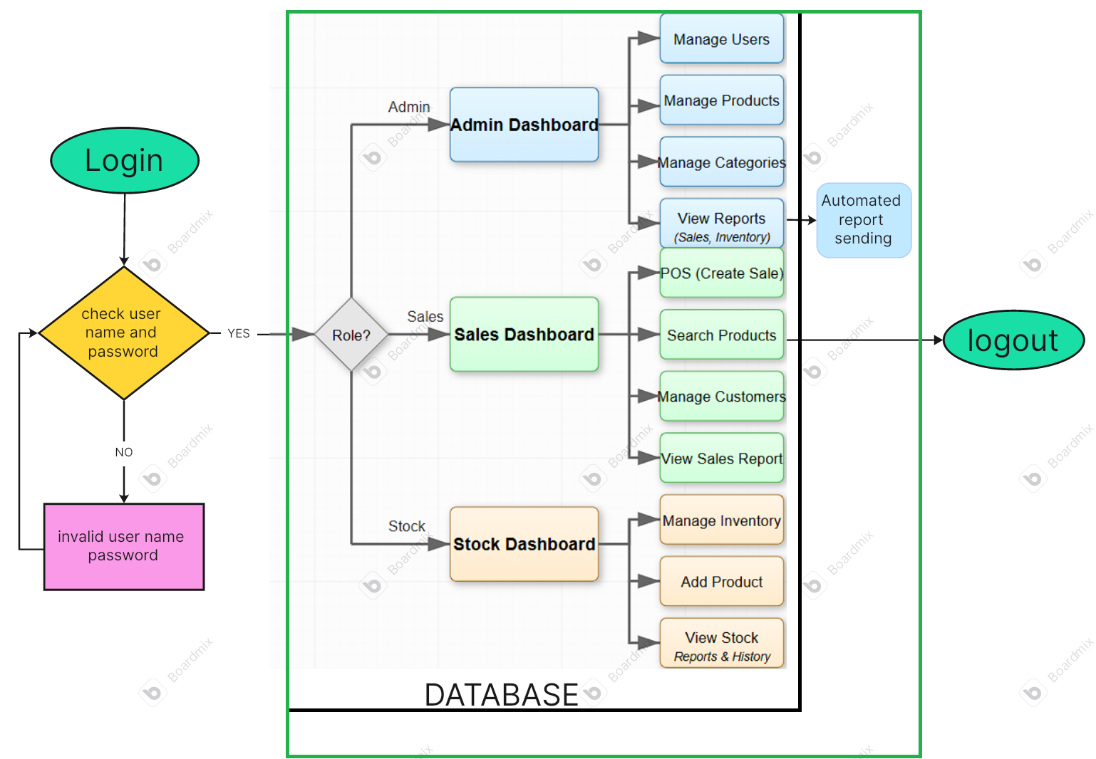

  - E-R DIAGRAM

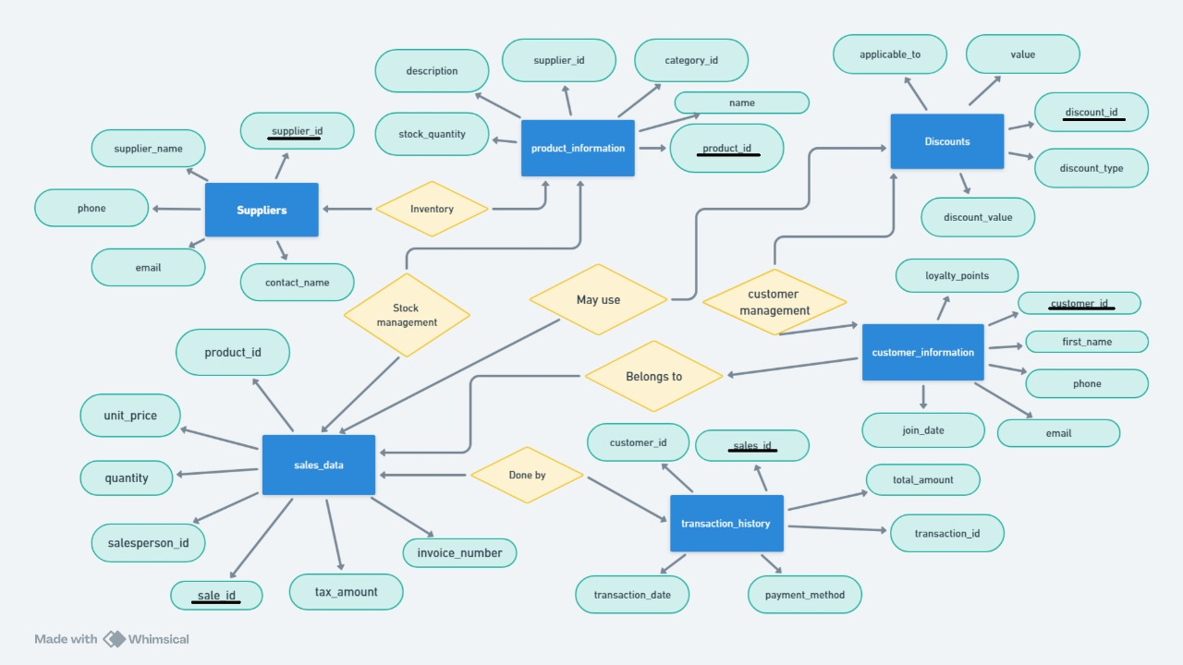
  - SCHEMA DIAGRAM
Category table

Discount table
Payment table
Product table
Sales table
Sales transaction table
Stock movement:
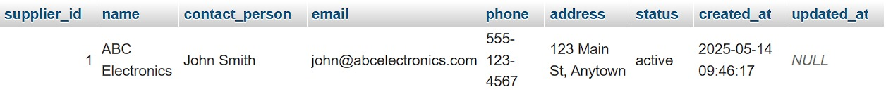
Suppliers:
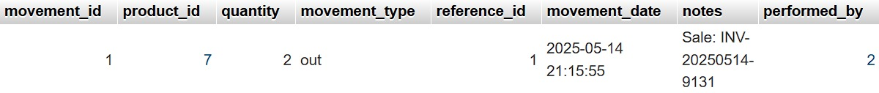
Users:

CHAPTER 3 SOFTWARE REQUIREMENTS

3.1 Front End
The front-end of the Retail Point of Sale (POS) System is developed using HTML, CSS, and JavaScript. HTML (HyperText Markup Language) is used to create the basic structure and layout of the web pages. CSS (Cascading Style Sheets) enhances the design and presentation, ensuring the interface is visually appealing and user-friendly. JavaScript is used to add interactivity and responsiveness, enabling features like real-time form validation, dynamic updates, and improved user experience without needing to reload the page. This combination ensures that the system is intuitive and efficient for cashiers and store staff to operate.

3.2 Back End

The back-end of the system is powered by PHP and MySQL. PHP (Hypertext Preprocessor) is a server-side scripting language that handles business logic, processes client requests, and manages server operations such as adding sales records, updating inventory, and generating invoices. MySQL is used as the relational database management system, where all essential data—such as products, customers, employees, sales, and suppliers—are stored and retrieved. PHP interacts with MySQL to perform CRUD operations (Create, Read, Update, Delete) and ensures secure, reliable data handling. Together, PHP and MySQL provide a robust, scalable, and secure backend infrastructure for the POS system.

CHAPTER 4

MODULE DESCRIPTION

4.1Sales Processing Module:
The Sales Processing Module is the core component of the Retail POS system, enabling salespersons to efficiently process customer transactions. This module includes
- Point of Sale Interface: An intuitive interface for adding products to cart, applying discounts, calculating taxes, and completing sales transactions
- Real-time Inventory Updates: Automatically adjusts product stock quantities upon successful sales
- Multiple Payment Methods: Support for cash, credit card, mobile payments with integration capabilities
- Customer Assignment: Link sales to specific customer profiles for building purchase history
- Receipt Generation: Automatic generation of detailed sales receipts with transaction information
- Sale Cancellation and Returns: Processing of returned items and managing sale cancellations
- Price Override: Authorized price adjustments with proper security controls
4.2Inventory Management Module:
The Inventory Management Module handles all aspects of product tracking and stock control
- Product Catalog Management: Comprehensive database of products with details including SKU, name, description, images, and pricing
- Stock Level Monitoring: Real-time tracking of inventory levels with alerts for low stock

- Stock Adjustment: Tools for adding inventory, recording damaged goods, and reconciling discrepancies
- Minimum Stock Thresholds: Automatic notifications when products reach predefined minimum stock levels
- Supplier Management: Tracking of product suppliers with contact information and purchase history
- Multi-category Support: Organization of products into hierarchical categories for better management
- Barcode/SKU Integration: Quick product lookup and processing using barcode scanners

4.3. Customer Management Module:
The Customer Management Module maintains detailed customer records and relationships
- Customer Database: Comprehensive customer profiles including contact information and addresses
- Purchase History: Tracking of all transactions associated with each customer
- Customer Segmentation: Classification of customers based on purchase patterns and preferences
- Loyalty Management: Features for tracking customer loyalty metrics and purchase frequency
- Customer Communication: Tools for managing customer communications and notifications
- Analytics Integration: Data collection for customer behavior analysis and personalized marketing

4.4 Invoice Generation Module:
The Invoice Generation Module creates professional documentation for sales
- Professional Receipt Design: Clean, branded layout with all transaction details
- Digital and Print Options: Support for both digital (email, PDF) and printed receipts
- Custom Receipt Information: Configurable receipt content including store details, return policies, and promotional messages
- Tax Calculations: Automatic application of appropriate tax rates with itemized display
- Discount Documentation: Clear notation of applied discounts and promotions
- Payment Method Recording: Documentation of payment methods used for transactions
- Receipt Lookup: Ability to retrieve and reprint historical receipts

4.5. Reporting and Analytics Module:
The Reporting and Analytics Module provides insights into business performance
- Sales Performance Metrics: Detailed reports on sales trends, top-selling products, and revenue analysis
- Inventory Reports: Stock level reports, inventory valuation, and movement analysis
- Financial Summaries: Profit margins, cost analysis, and revenue breakdowns
- Custom Report Generation: Flexible reporting tools with various filtering options
- Sales Forecasting: AI-driven predictive analytics for future sales trends

- Interactive Dashboards: Visual representation of key performance indicators
- Export Capabilities: Support for exporting reports in various formats (PDF, CSV, Excel)

4.6. Automated Daily Reports Through Email:
The Automated Daily Reports feature streamlines business intelligence delivery
- Scheduled Report Generation: Automatic creation of daily sales and performance reports
- Customizable Content: Configurable report templates with relevant metrics and KPIs
- Email Integration: Seamless delivery of reports to designated recipients using Gmail API
- Visual Data Representation: Inclusion of charts and graphs for better data visualization
- Historical Comparison: Comparative analysis against previous periods to identify trends
- Data Security: Secure authentication using OAuth2 for Google services
- Failure Notifications: Alert system for report generation or delivery issu

IMPLEMENTATION

SOURCE CODE LOGIN.HTML
<?php
// Start session
session_start();

// If user is already logged in, redirect to the appropriate dashboard
if (isset($_SESSION['user_id'])) {
if ($_SESSION['role'] === 'admin') {
header('Location: ../admin/dashboard.php');
} elseif ($_SESSION['role'] === 'salesperson') {
header('Location: ../salesperson/dashboard.php');
} elseif ($_SESSION['role'] === 'stock_manager') {
header('Location: ../stock_manager/dashboard.php');
}
exit;
}

// Process login request
$error_message = "";
if ($_SERVER['REQUEST_METHOD'] === 'POST') {
require_once '../config/database.php';
$conn = getConnection();

// Sanitize inputs
$username = sanitizeInput($_POST['username'], $conn);
$password = $_POST['password']; // We'll verify the password directly against database

// Query to check user credentials
$query = "SELECT user_id, username, full_name, role, status FROM users WHERE username = ? AND password = ? AND status = 'active'";
$stmt = $conn->prepare($query);

$stmt->bind_param("ss", $username, $password);
$stmt->execute();
$result = $stmt->get_result();

if ($result->num_rows === 1) {
$user = $result->fetch_assoc();

// Set session variables
$_SESSION['user_id'] = $user['user_id'];
$_SESSION['username'] = $user['username'];
$_SESSION['full_name'] = $user['full_name'];
$_SESSION['role'] = $user['role'];

// Update last login time
$update_query = "UPDATE users SET last_login = NOW() WHERE user_id = ?";
$update_stmt = $conn->prepare($update_query);
$update_stmt->bind_param("i", $user['user_id']);
$update_stmt->execute();
$update_stmt->close();

// Redirect to appropriate dashboard based on role
if ($user['role'] === 'admin') {
header('Location: ../admin/dashboard.php');
} elseif ($user['role'] === 'salesperson') {
header('Location: ../salesperson/dashboard.php');
} elseif ($user['role'] === 'stock_manager') {
header('Location: ../stock_manager/dashboard.php');
}
exit;
} else {
$error_message = "Invalid username or password. Please try again.";
}

// Close the database connection
mysqli_close($conn);
}
?>

<!DOCTYPE html>
<html lang="en">
<head>
<meta charset="UTF-8">
<meta name="viewport" content="width=device-width, initial-scale=1.0">
<title>Retail POS - Login</title>
<link rel="stylesheet" href="/dbms_project/assets/css/style.css">
<!-- Font Awesome for icons -->
<link rel="stylesheet" href="https://cdnjs.cloudflare.com/ajax/libs/font-awesome/5.15.3/css/all.min.css">
</head>
<body class="login-page">
<div class="login-container">
<div class="login-header">
<h1>Retail POS System</h1>
<p>Enter your credentials to access the system</p>
</div>

<?php if (!empty($error_message)): ?>
<div class="alert alert-danger">
<?php echo $error_message; ?>
</div>
<?php endif; ?>

<form class="login-form" action="index.php" method="post">
<div class="form-group">
<label for="username"><i class="fas fa-user"></i> Username</label>
<input type="text" id="username" name="username" required>
</div>

<div class="form-group">
<label for="password"><i class="fas fa-lock"></i> Password</label>
<input type="password" id="password" name="password" required>
</div>

<div class="form-actions">
<button type="submit" class="btn btn-primary btn-block">
<i class="fas fa-sign-in-alt"></i> Login
</button>
</div>
</form>

<div class="login-footer">
<p>&copy; <?php echo date('Y'); ?> Retail POS System. All rights reserved.</p>
</div>
</div>

<style>
body.login-page {
background-color: #f8f9fa;
height: 100vh;
margin: 0;
display: flex;
align-items: center;
justify-content: center;
font-family: Arial, sans-serif;
}

Home Page

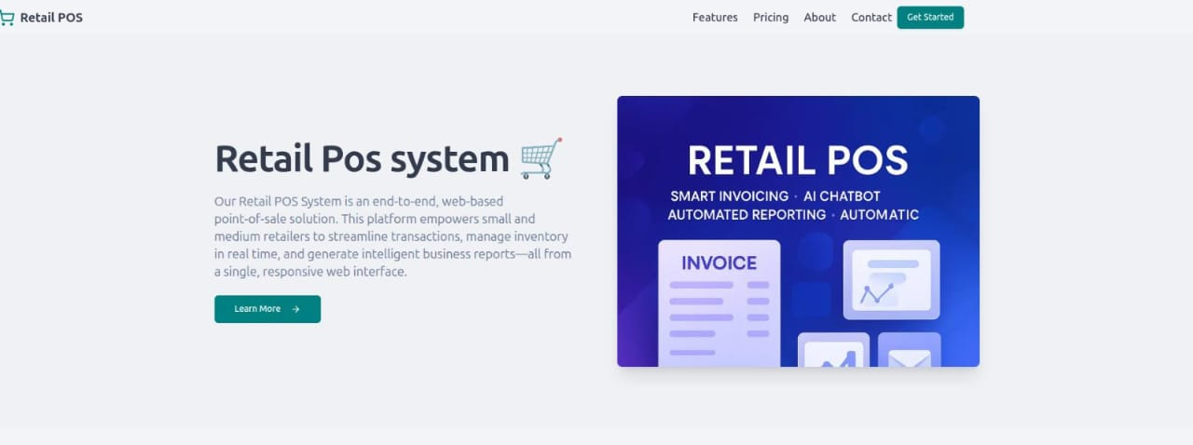

Login/Signup Page

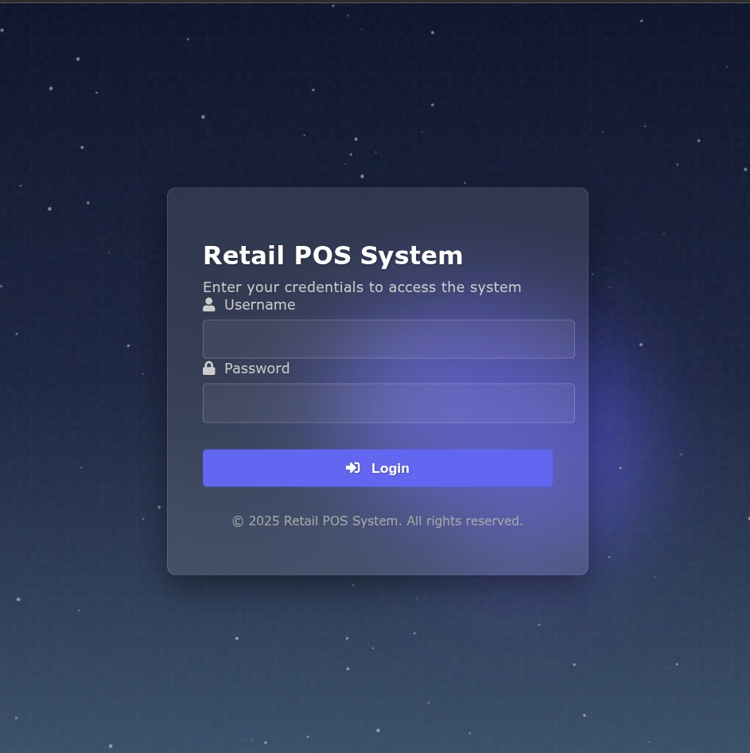
CHAPTER 6 SNAPSHOT

Dashboard Page
admin
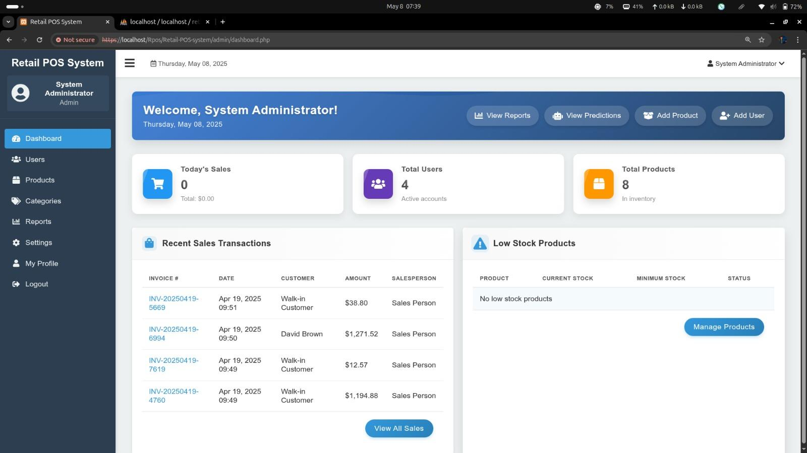

Salesperson
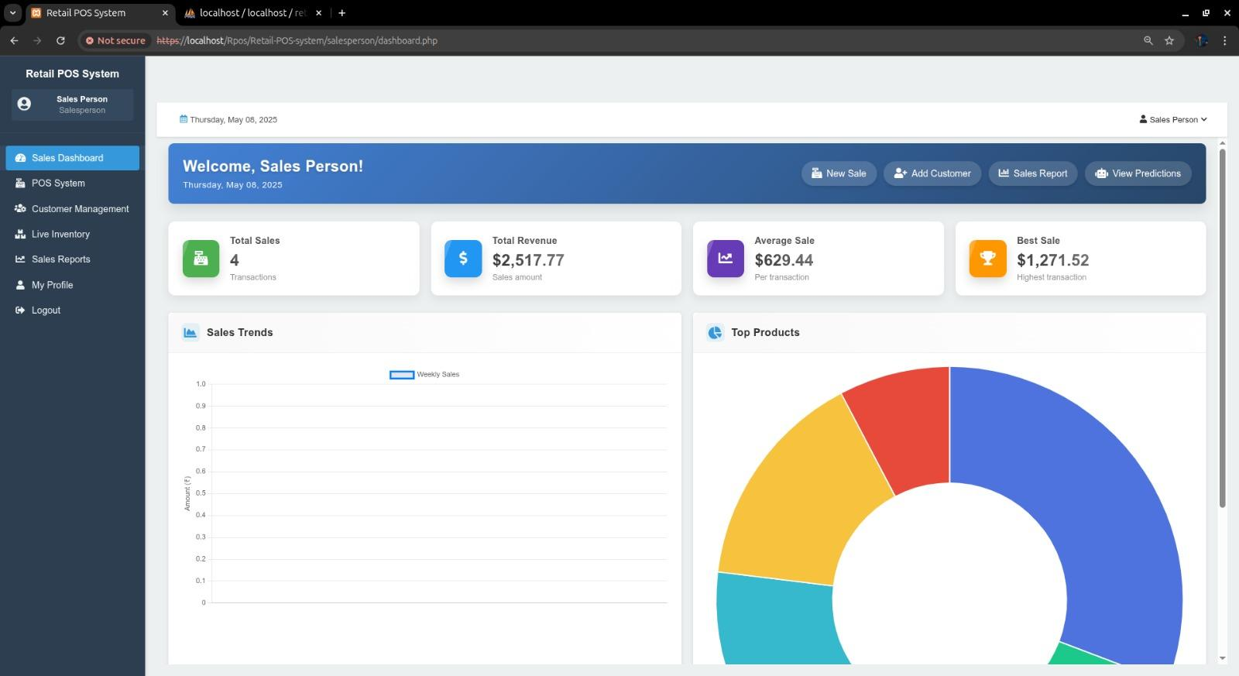

Sales Page
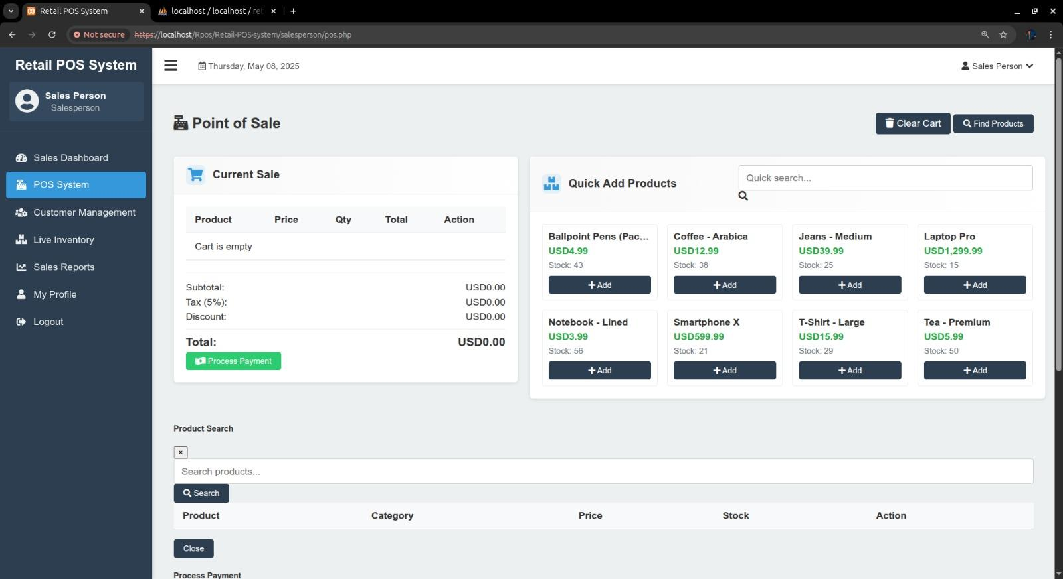

Admin’s Profile Page
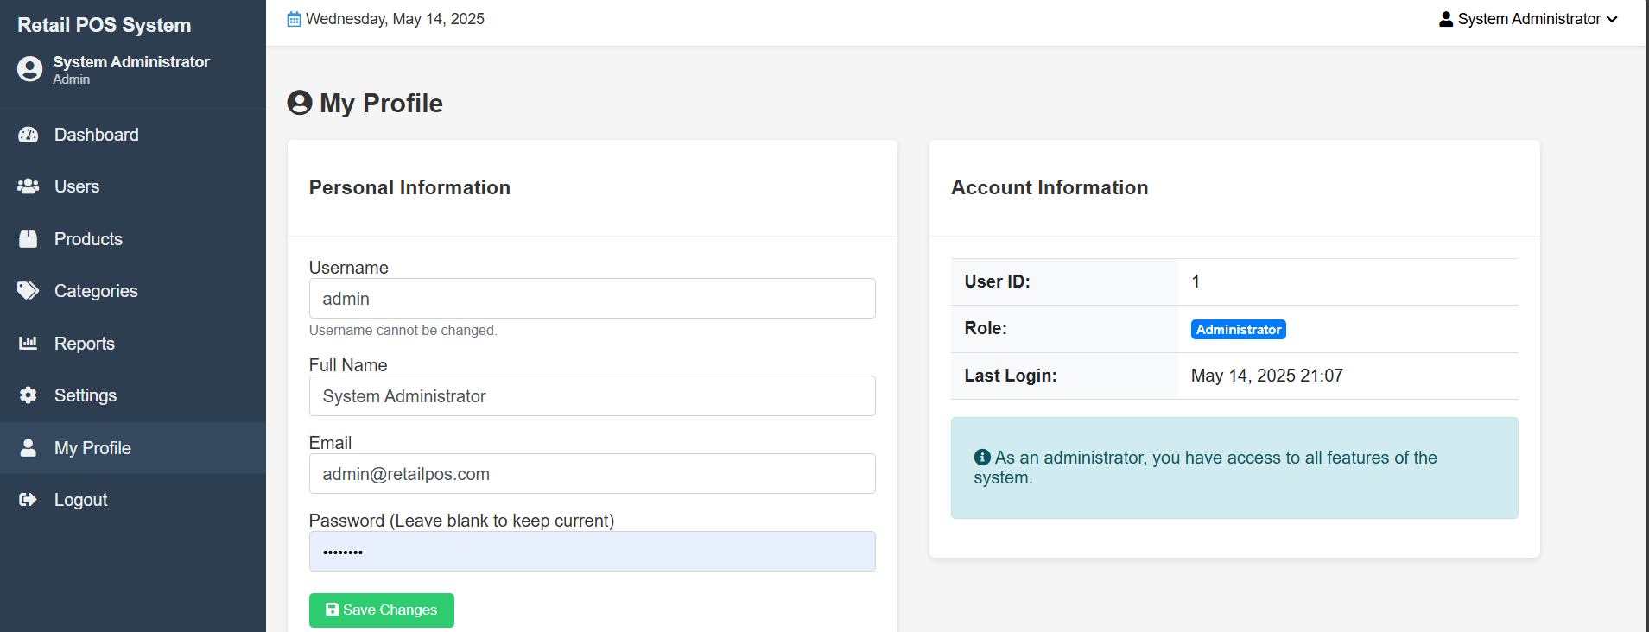

stock Dashboard Page
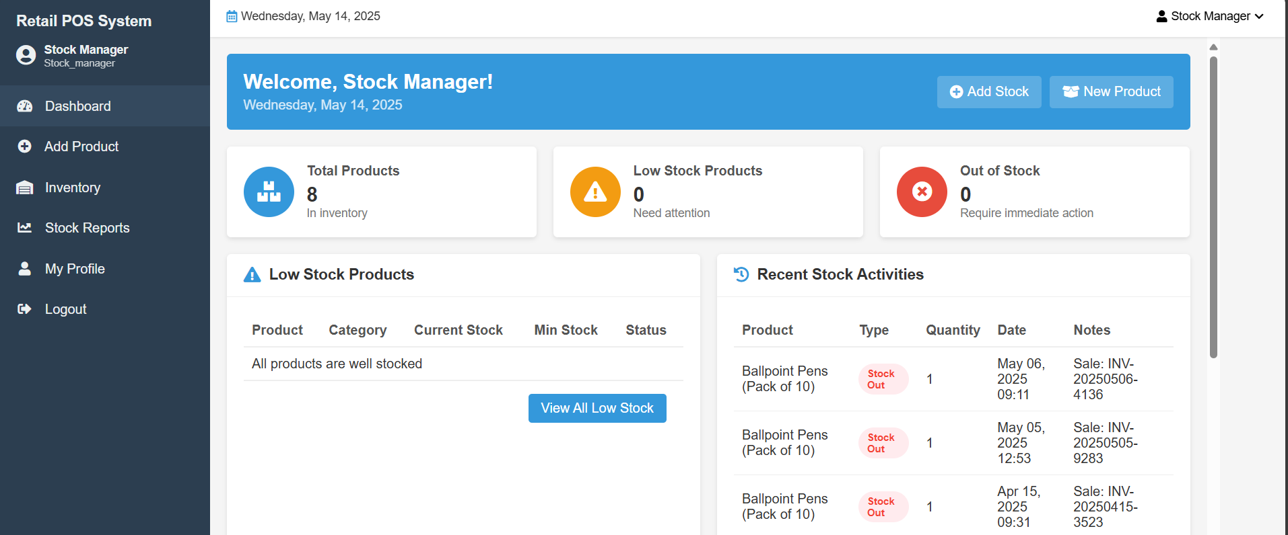
Customer Management Screenshot

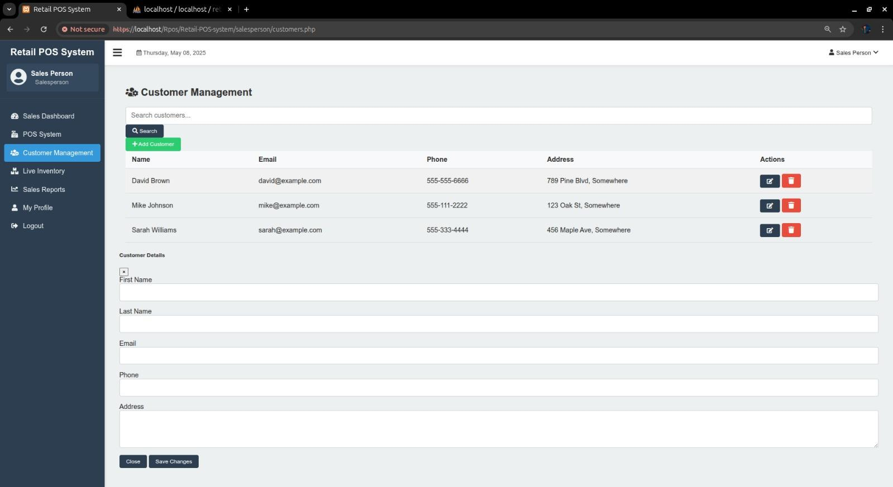
Inventory Screenshot
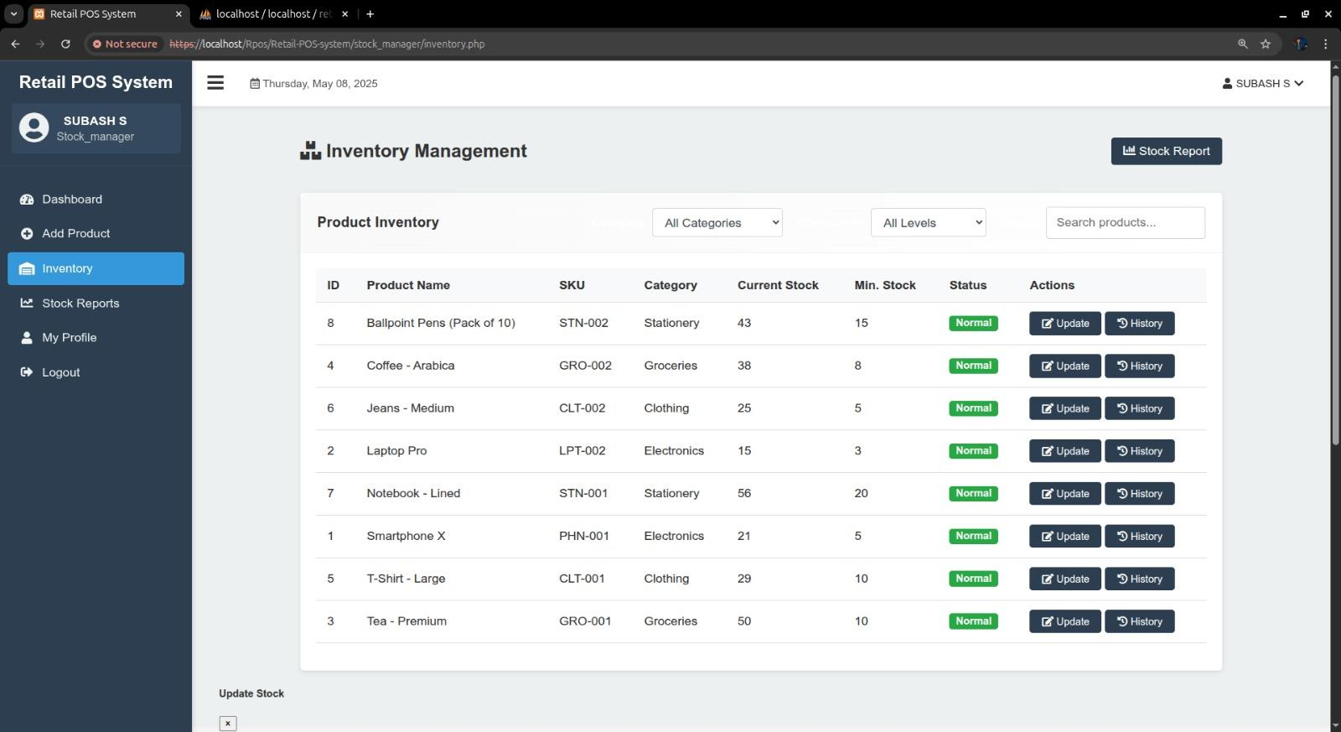
Receipt

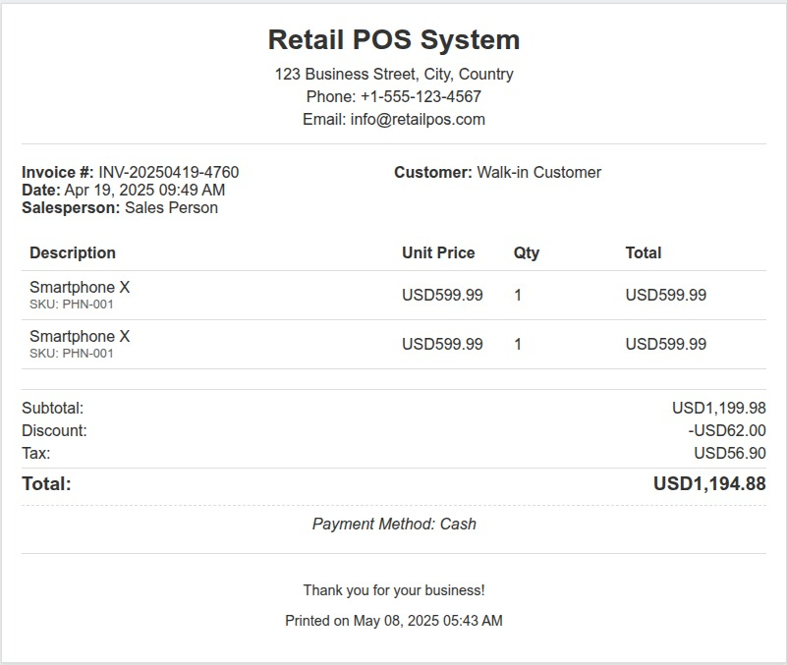

Transaction
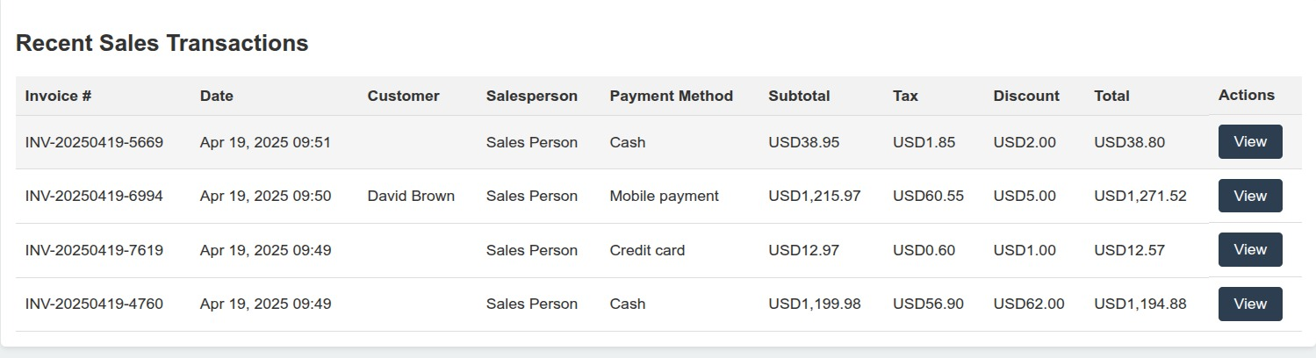

Inventory page


Report page
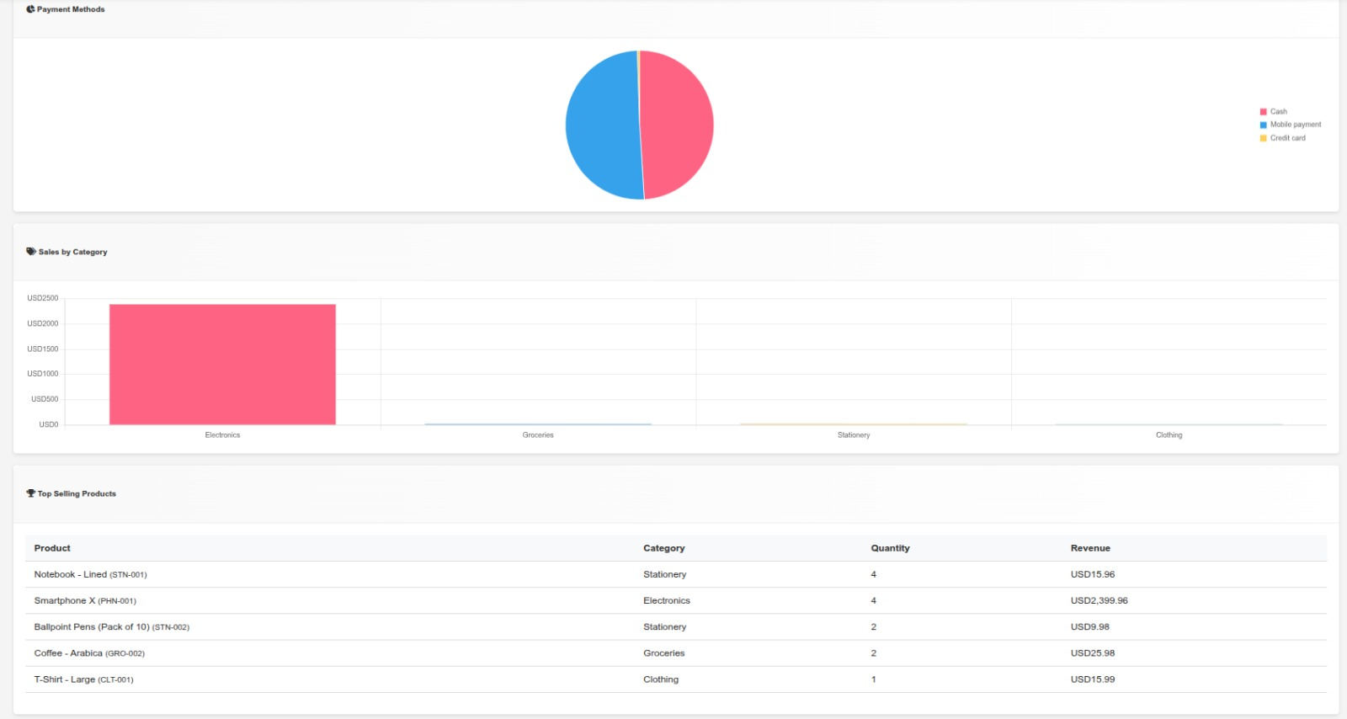

Prediction Screenshot

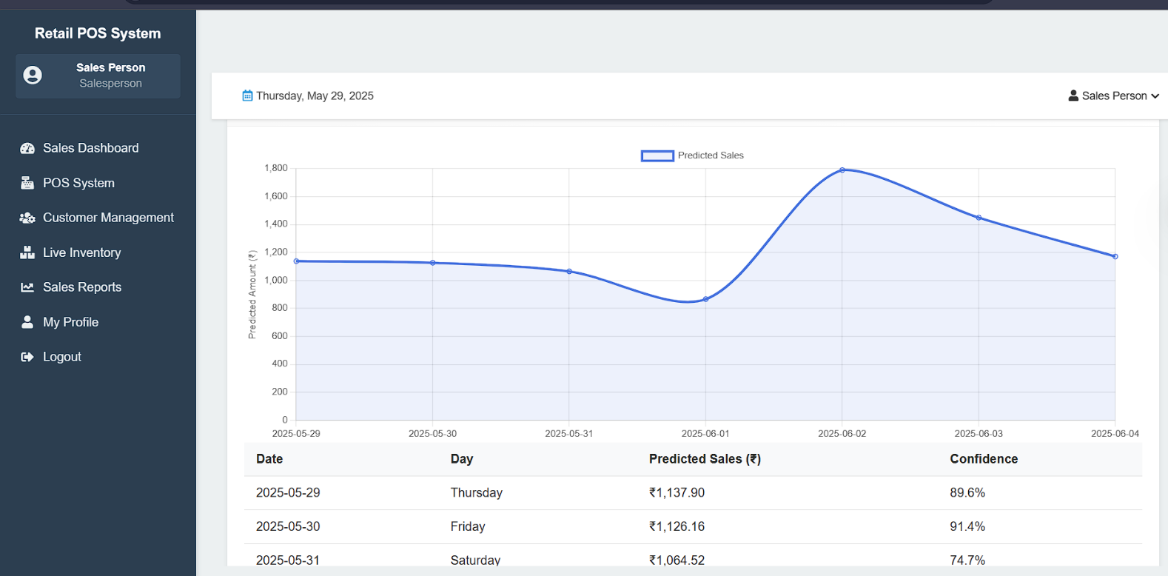
Automated Daily Report
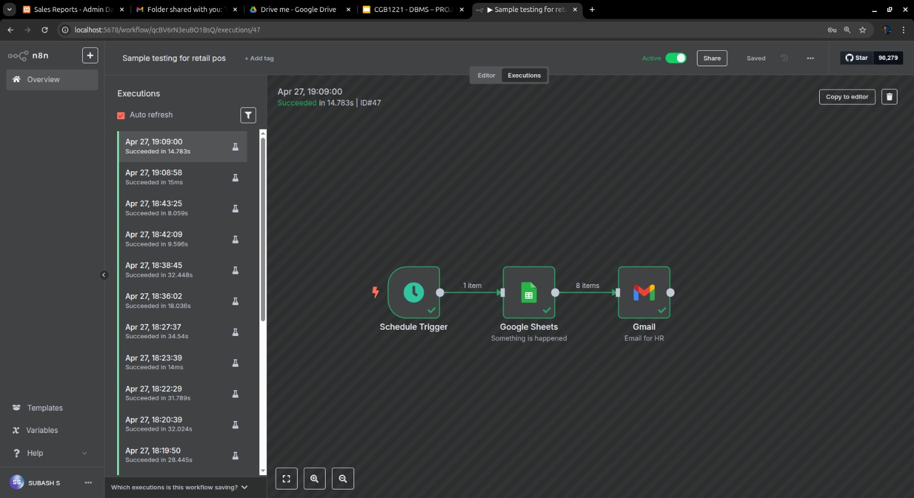

CONCLUSION
The Retail Point of Sales (POS) System developed in this project efficiently integrates key functionalities such as transaction processing, inventory management, and customer relationship tracking. The system ensures real-time data updates and accuracy, enhancing operational efficiency. Challenges like data synchronization and user interface design were addressed effectively. It offers valuable insights through report generation, aiding decision-making. The system improves accuracy, reduces errors, and enhances customer experience. It is a scalable solution, adaptable to the growing needs of retail businesses. Future improvements may include advanced analytics and more payment options.

REFERENCES

    - Zakyu Retail POS System Design and Architecture. Retrieved from https://www.zakya.com/en-in/

    - Oracle. (2022). Implementing Point of Sale Systems for Retail Businesses. Oracle Documentation. Retrieved from https://docs.oracle.com

